Based on the model that we built and optimized, there are four factors that have significant effects on ticket price, including fastQuads, runs, Snow Making acs and vertical drops (see Figure below).

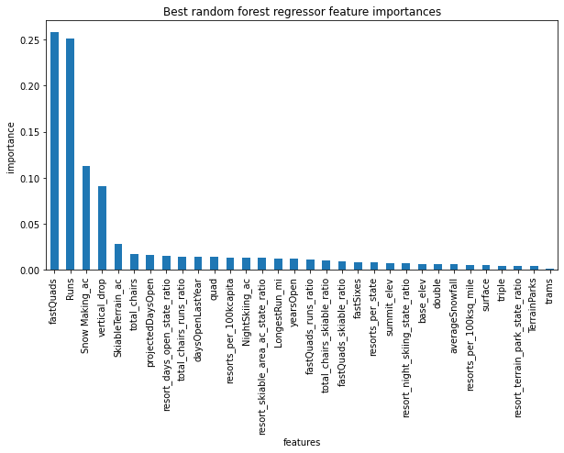

Further investigation demonstrated that Big Mountain resort’s fastQuads, Runs, Snow Making ac and vertical drop are among the Top tier in the nation but the ticket price is at the middle range. (see figures below)

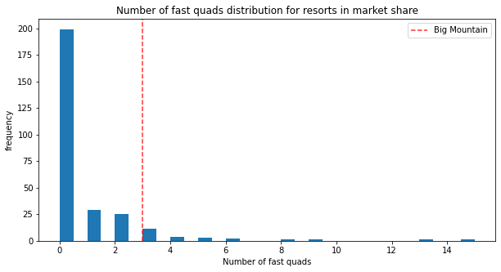

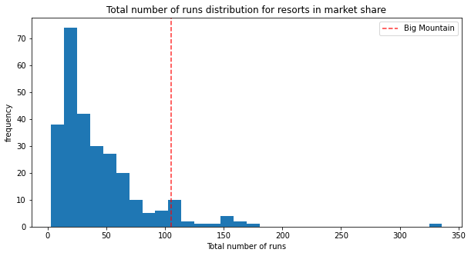

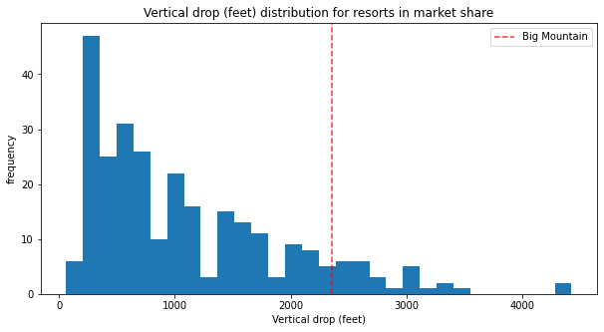

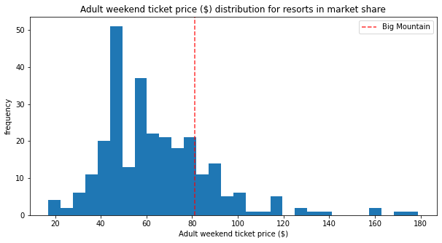

Our model predicts that with current settings, the ticket price for Big Mountain resort could be as high as $95.87 per person, which suggests that we should be able to optimize some of the features listed above in order to reduce operating cost while maintaining ticket price at the same or even higher levels.

Detailed data analysis revealed that by terminating 5 runs, it will be only decrease ticket price by 0.66 and total revenue of 1155000 dollars, while the operating cost will be significantly reduced.

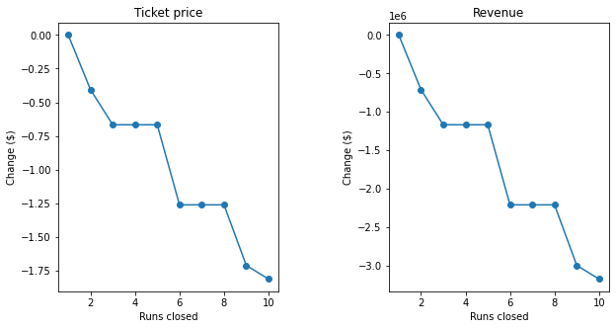

In addition, adding a run, increasing the vertical drop by 150 feet, and installing an additional chair lift will increase ticket price by 1.99 and total revenue by 3474638, which will not only make up the reduction in revenue due to closing 5 runs but also bring in ~2.2 million dollar revenue every year.

Based on above, we recommend the following comprehensive solution:

1. Close five existing runs and open a new run (or Close 4 runs instead)
2. Increase the current vertical drop by 150 feet
3. Installing an additional chair lift
4. Increase ticket price by 2 dollars

We projected to have a ~2 million yearly increase in revenue after implementing those changes.